Programming Fundamentals
Assignment # 3



- Name: Ahmed Ali
- Department : BSCS
- Department : Computer Science
- Section: C
- Roll Number: 2514119-094
- Semester: 1

Submitted to: Sir Tasaddaq Latif

Question #1 : Find the Error of the following code. If no error then write output.

a :

#include <iostream>
using namespace std;
int main()
{
int I, j;

for (I = 1; I >= 7; I++)
cout << I;

cout << "end of program";
return 7;
}

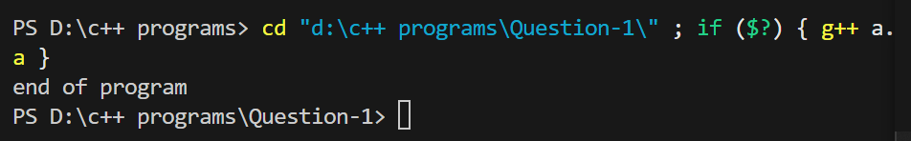

B :

#include <iostream>
using namespace std;
int main()
{
int num1 = 11, num2 = 10;

if (num1 < num2)
cout << "num1 is the smallest";
num1 = num2;
else
cout << "num2 is smallest";
return 0;
}

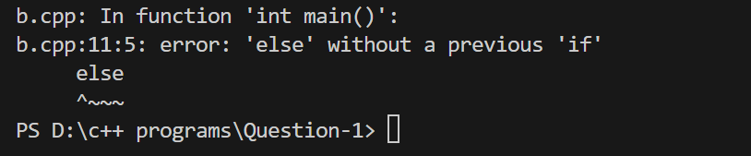

C :

#include <iostream>
using namespace std;
int main()
{
int a = 0, b = 1;
a = b++;
cout << a << b;
b = ++a;
cout << a << b;
return 0;
}

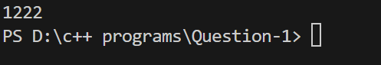

D :

#include <iostream>
using namespace std;
int main(){
cout<<"enter values";
int a,b,res;
cin>>a;cin>>b;
a=20;b=10;
a+b=res;
cout<<"res ="<<res;
return 0;
}

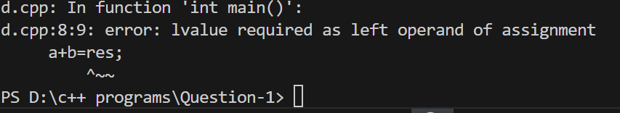

Question #3 : Write a program that read height in inches and display the height in feet and inches.

#include <iostream>
using namespace std;
int main(){
float inches,feet;
cout<<"Enter height in inches";
cin >>inches;
feet=inches/12;
cout<<"Your height in feet = "<<feet<<endl;

}

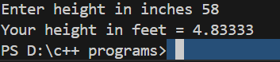

Question #4 : Write a program that take two numbers form user. Find if the first number is multiple of second number.

#include <iostream>
using namespace std;
int main(){
int num1,num2;
cout<< "enter two numbers";
cin>>num1>>num2;
if(num1%num2== 0){
cout<<"your number is multiple of second number";
}
else{
cout<<"your number is not multiple of second number";
}
return 0;
}

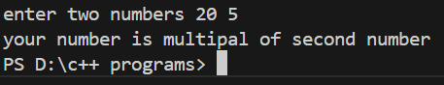

Question #5 : Write a program that read 10 numbers from the user and display their sum , maximum a minimum number.

#include <iostream>
using namespace std;
int main()
{
int num, sum = 0, max=0, min=9999;
cout << "Enter 10 Number: ";
for (int i = 0; i < 10; i++)
{
cin >> num;
sum = sum + num;
if(max<num) {
max=num;
}
if(min>num) {
min=num;
}
}

cout <<"\nsum of numbers is\t"<< sum;

cout <<"\nmax of these number\t"<< max;

cout <<"\nmin of these number\t"<< min;
return 0;
}

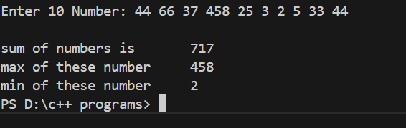

-------------------------------------------------------------------------------------------------------------------------------

Array Sorting Program

#include <iostream>
using namespace std;

const int n = 10;

// Function that take input

void inputarray(int ar[])
{
cout << "Enter " << n << " values of array";
for (int i = 0; i < n; i++)
{
cin >> ar[i];
}
}

// Function for sorting array

void sortArray(int ar[])
{
int temp;
for (int j = 1; j <= n; j++)
{
for (int i = 0; i < n; i++)
{
if (ar[i] > ar[i + 1])
{
temp = ar[i];
ar[i] = ar[i + 1];
ar[i + 1] = temp;
}
}
}
}

// Function for output

void output(int ar[])
{
cout << "Your array in assending order = ";
for (int i = 0; i < n; i++)
{
cout << ar[i] << " ";
}
}

// now main function

int main()
{
int ar[n];

inputarray(ar);
sortArray(ar);
output(ar);
}

